USE CASE DIAGRAM:
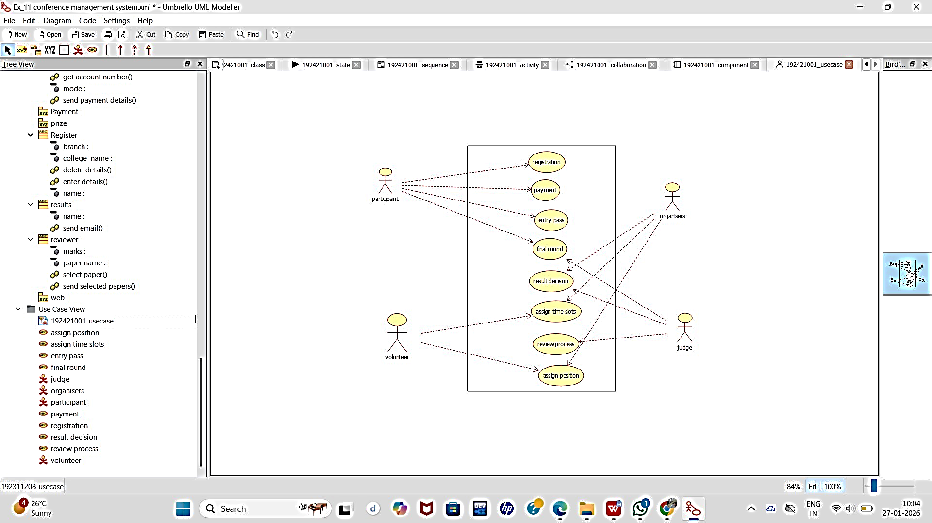

CLASS DIAGRAM:

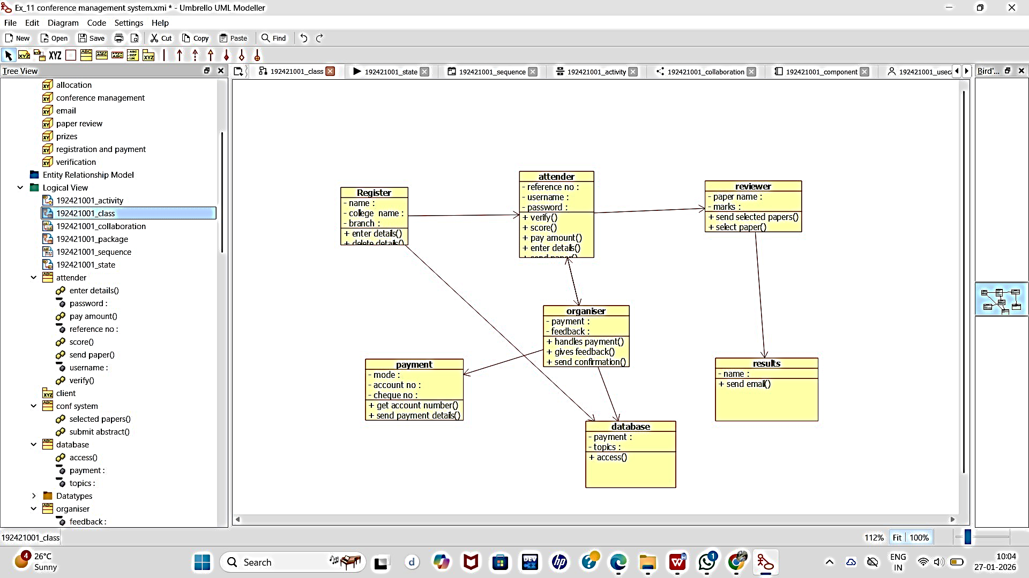

ACTIVITY DIAGRAM:

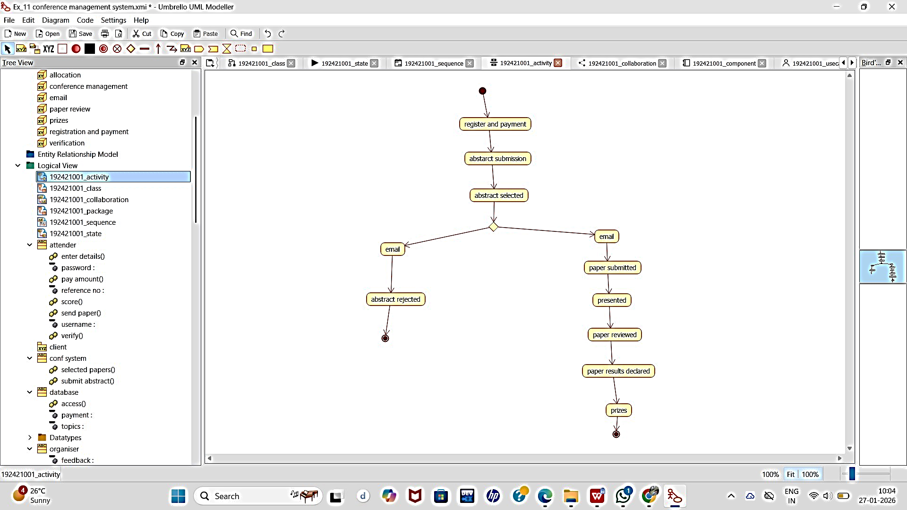

SEQUENCE DIAGRAM:

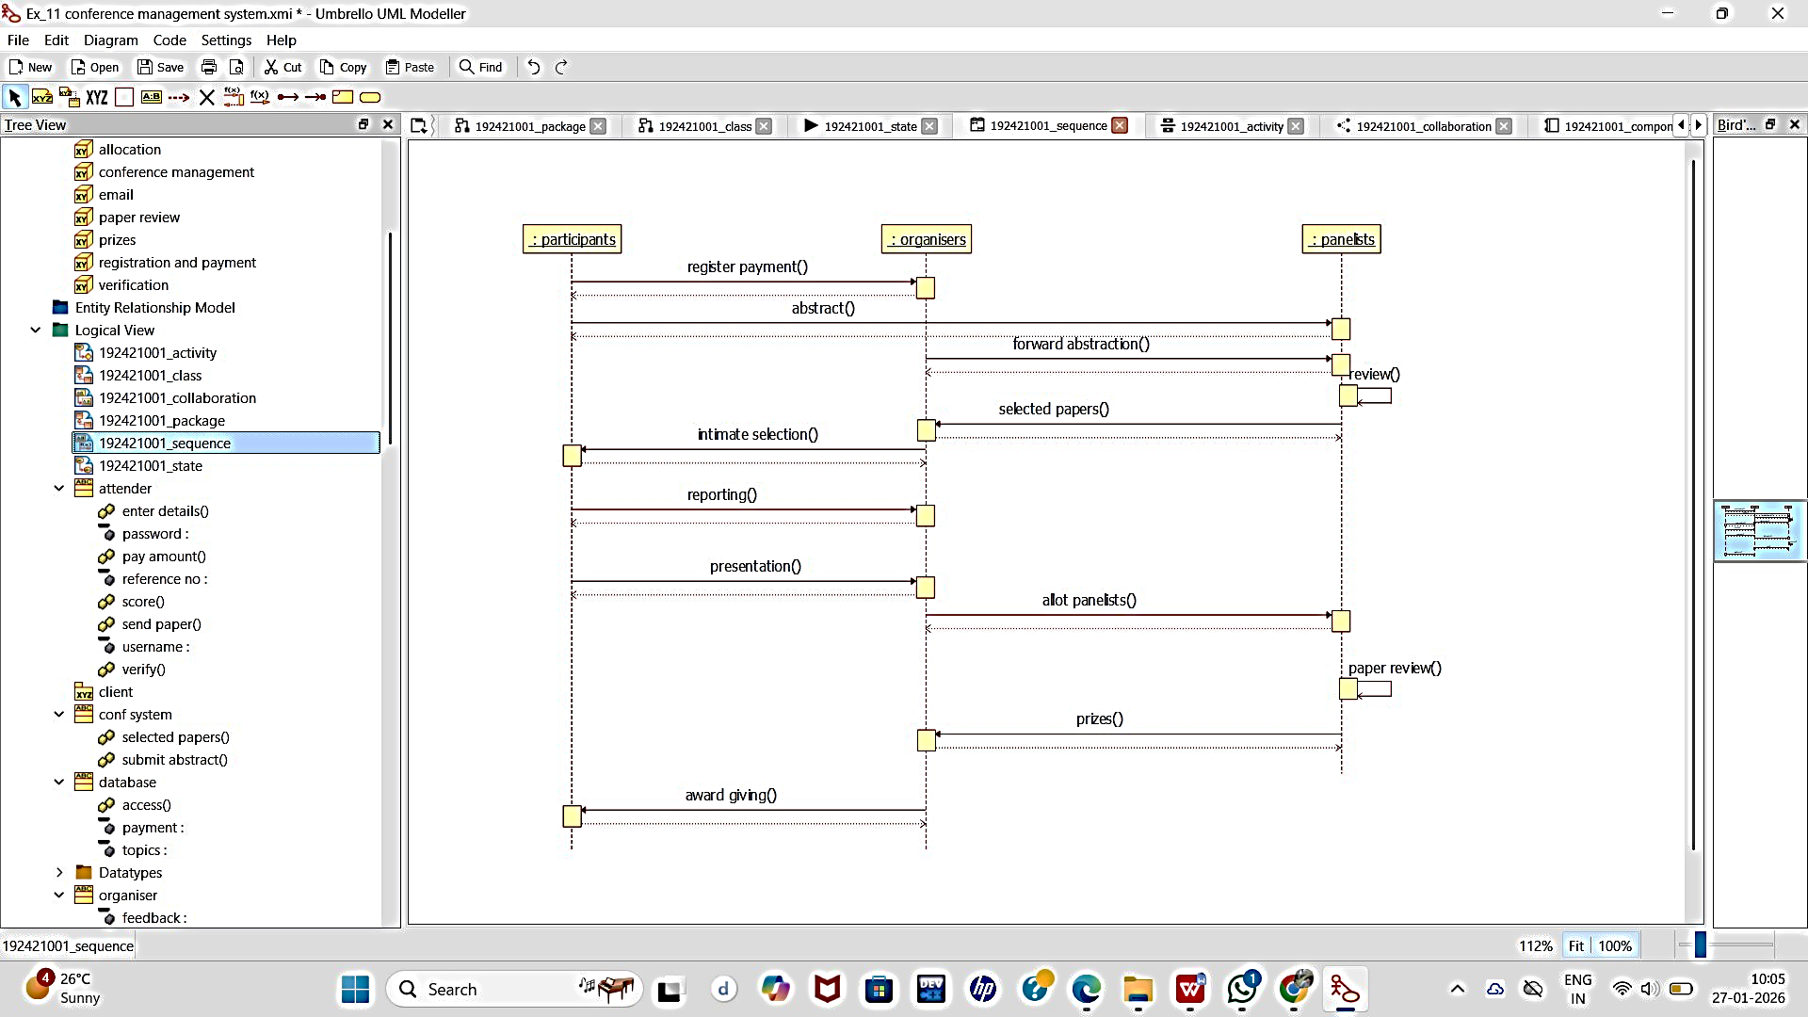

COLLABORATION DIAGRAM:

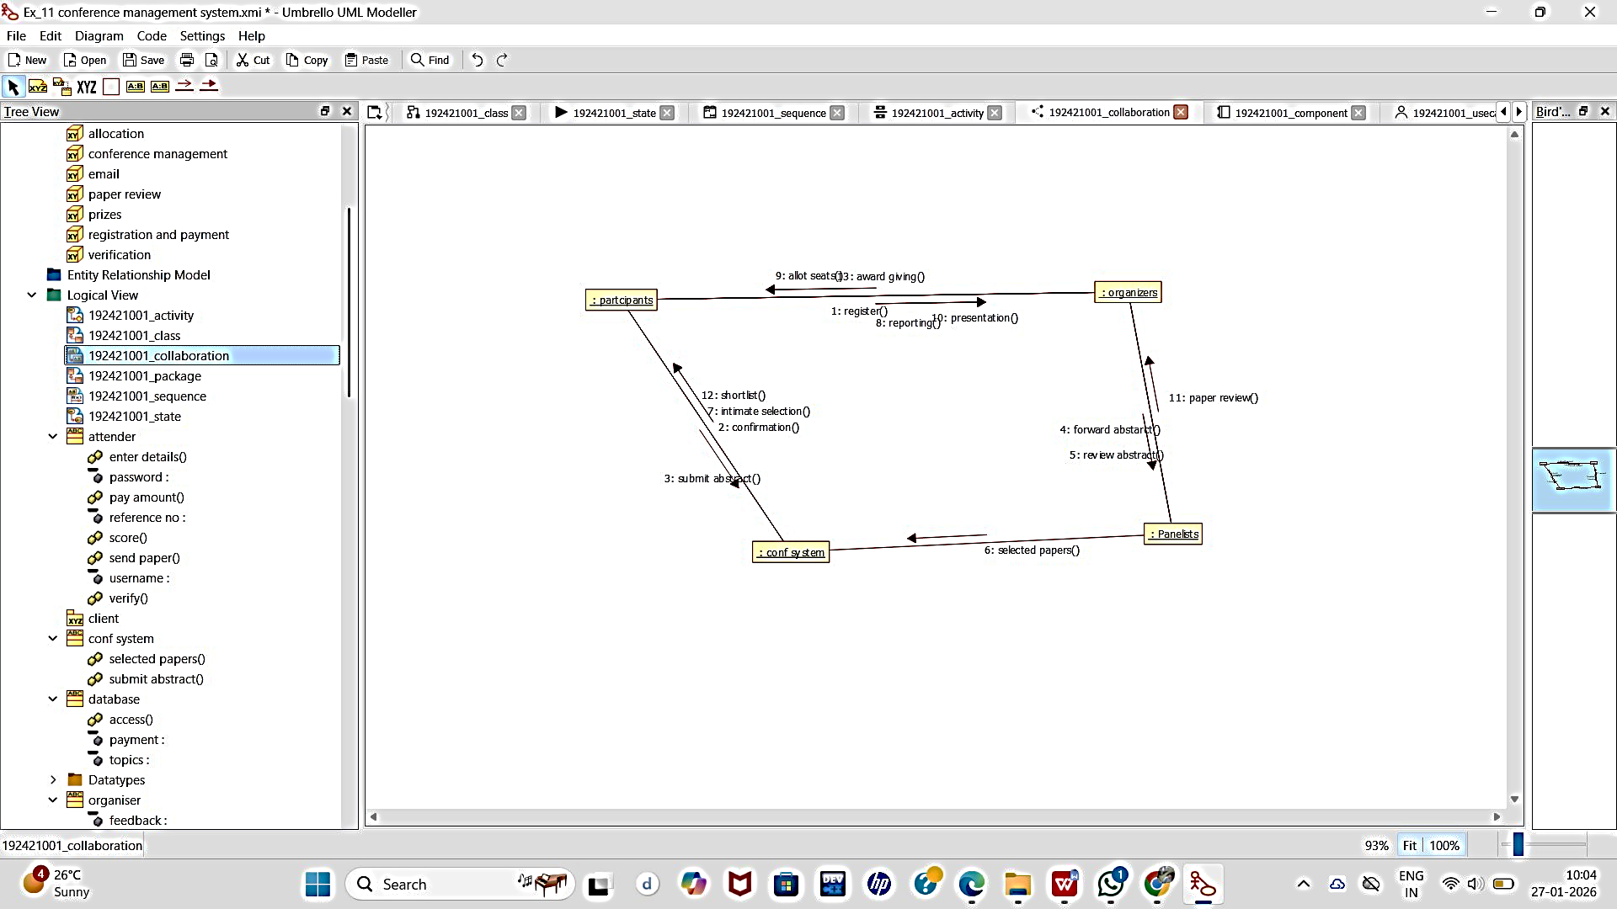

COMPONENT DIAGRAM:

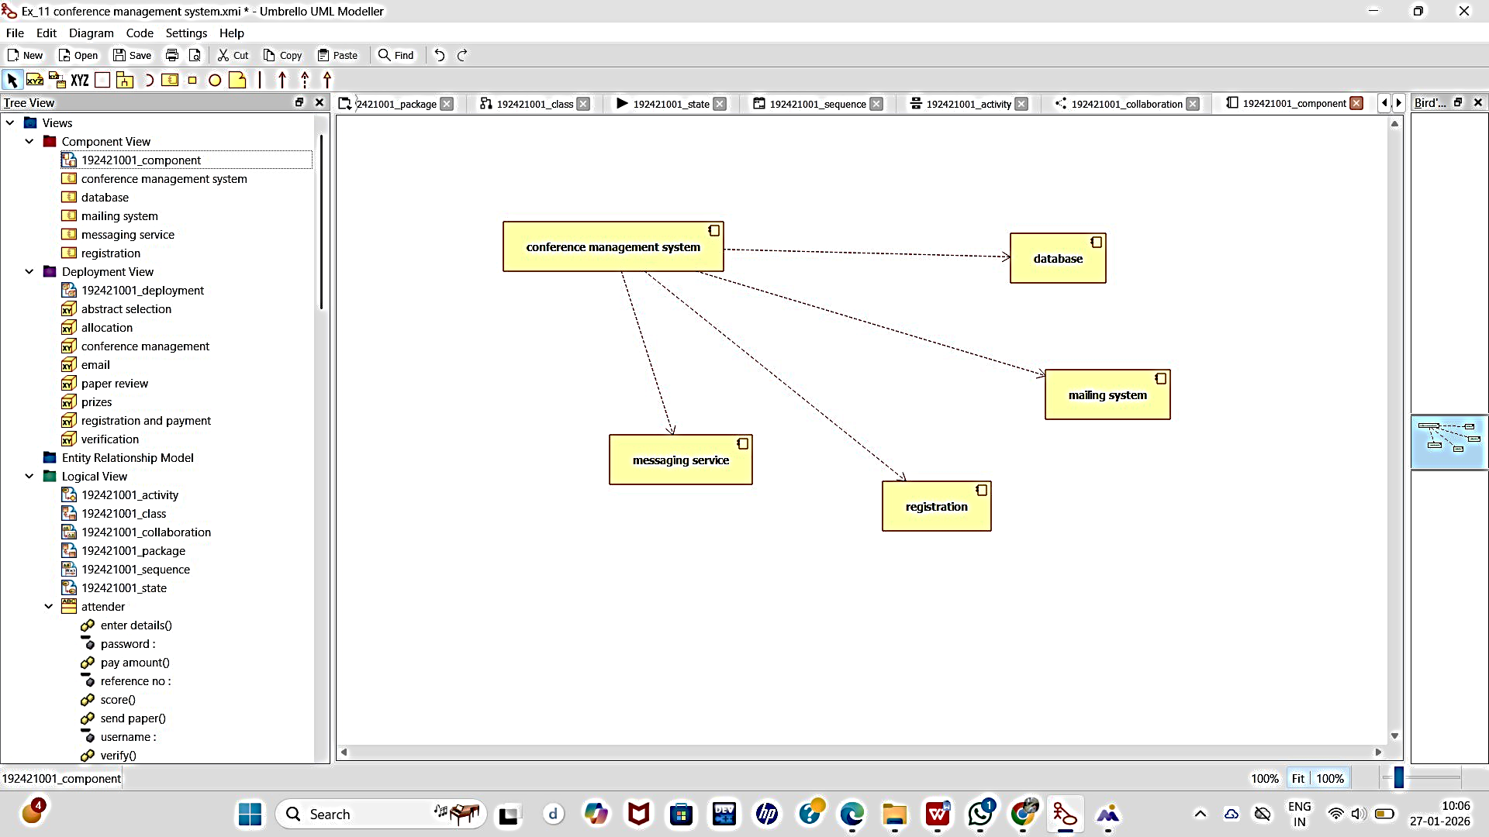

DEPLOYMENT DIAGRAM:

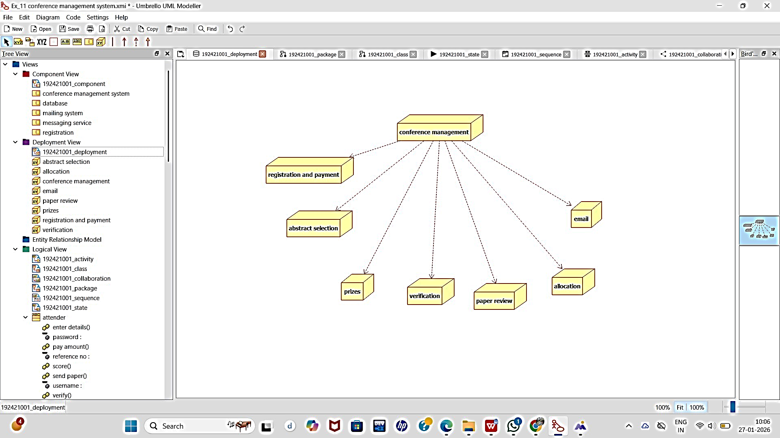

PACKAGE DIAGRAM:

